Global Flood Map ([www.globalfloodmap.org/Nigeria](http://www.globalfloodmap.org/Nigeria))



1. *High Plateau*

a. The north Central Plateau

b. The Eastern and North-eastern highlands

c. The Western Uplands

*2. Lowlands*

a. The Sokoto Plains

b. The Niger/Benue trough

c. The Chad Basin.

d. The interior coastal lowlands of western Nigeria

e. The lowlands and scarplands of south-eastern Nigeria.

f. The coastlands

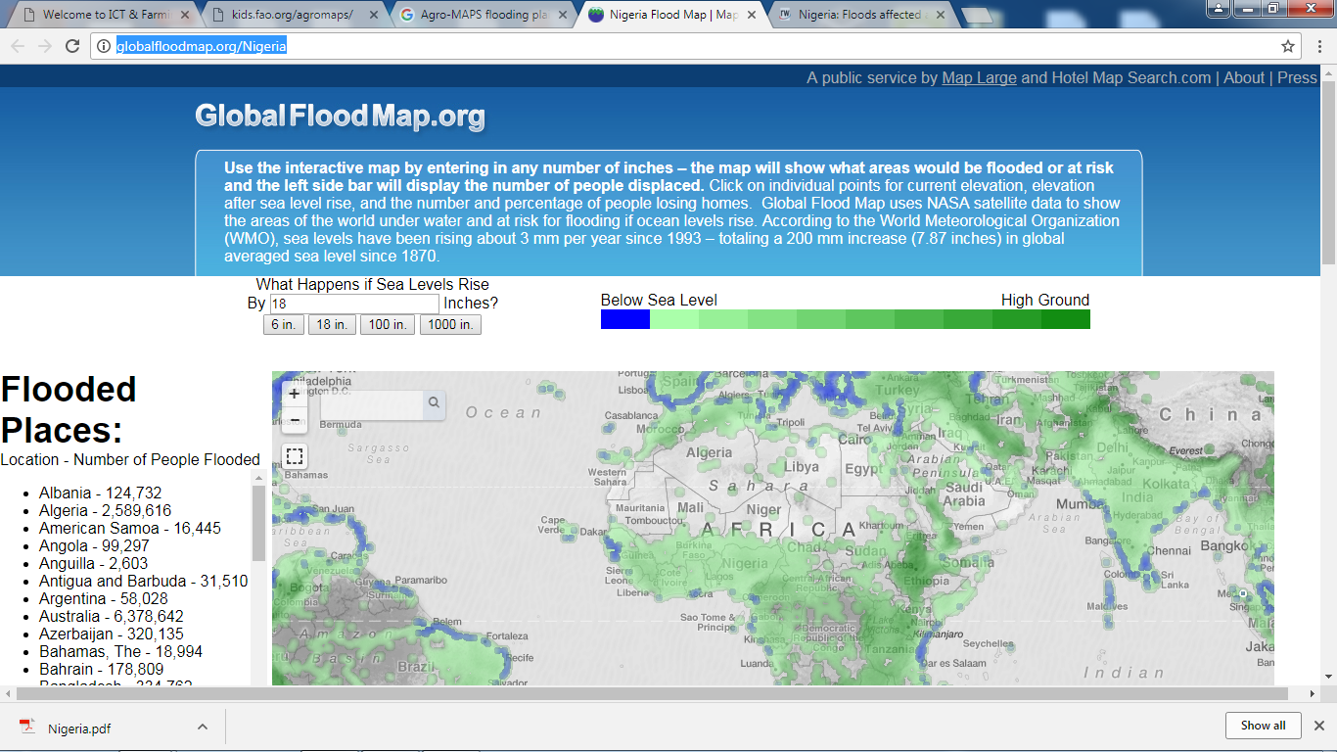

What Happens if Sea Levels Rises by 1000 inches?

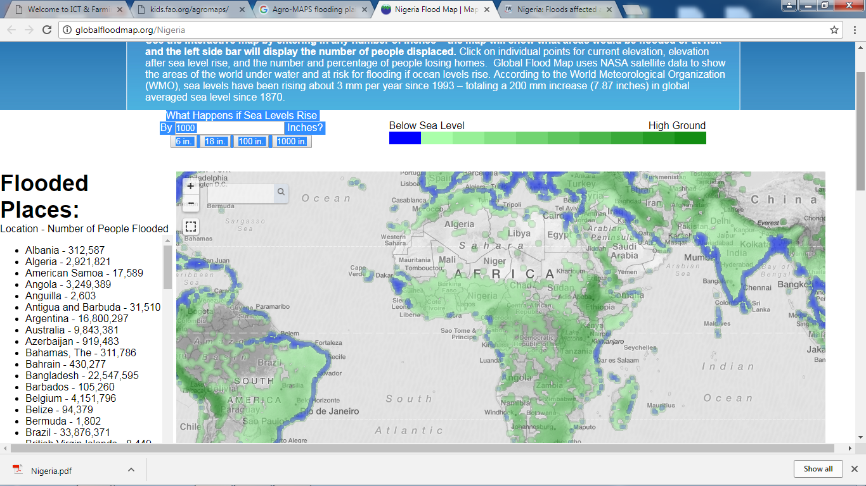

What Happens if Sea Levels Rises by 5000 inches?

